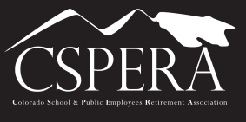

Colorado School and Public Employees Retirement Association
WORKING FOR RETIREMENT SECURITY

September 2020 – Vol. 3

NEWS YOU CAN USE!

Dear CSPERA Board Member:
"We received the following information from Secure PERA, and as CSPERA is a member of the Secure PERA Action Coalition, we wanted to share the information with our members."
The State Legislature is where the major decisions are made about PERA and your PERA benefit. They decide how much the employee should pay and what percentage your COLA should be. Its also where changes to PERA, like SB18-200, are debated and approved.
We asked 147 candidates for the State Legislature their thoughts on PERA. Not all of them responded, but of those who did, we reviewed their answers for agreement with Secure PERA's guiding principles (which you can find here) and their likelihood for success in their race. After our steering committee weighed these factors, we chose to endorse the following 59 candidates for State Senate and State House. We encourage you to visit their websites, learn more about them and help them by volunteering or donating.
If you aren't sure what Senate and House seat is yours, you can look them up here.
Please follow us on Twitter and Facebook to see the photos of those we have endorsed.
But, most importantly - DO NOT FORGET TO VOTE! Ballots start mailing on October 9th. Check your registration, see a sample ballot and find locations for returning your ballot at www.GoVoteColorado.com.
Secure PERA is proud to announce we have endorsed the following candidates. (View it on our website here.)

